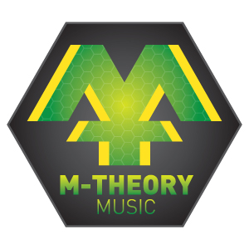
THATCHAM YOUTH
HEALTH AND SAFETY POLICY
M-Theory Music is committed to providing musical activities in a safe environment without risk as far as is reasonably practicable.
The overall responsibility for the implementation of this policy rests with the Mike Hawthorne as is the Day to day responsibility for ensuring this policy is put into practice.
All staff will be made aware of the content of this policy as part of the induction process and be encouraged to take responsibility for ensuring their own personal health and safety and that of others who may be affected by their actions.

Our current named person for Health & Safety is Mike Hawthorne.
M-Theory Music will:
- Take out and maintain adequate insurance to cover all possible liabilities and display this information publicly
- Provide equipment that is maintained in a safe condition at all times and provide instruction in its safe use
- Ensure that assessments are carried out in accordance with the Risk Assessment Policy
- Make sure that fire drills are undertaken on a regular basis
- Establish and display prominently on the premises emergency procedures to be taken in the event of fire, incidents, accidents and illness
- Maintain necessary health and safety records including an Accident Book
- Make sure that a First Aid box is regularly checked and its location known to all staff
- Ensure that a qualified first aider is present at all musical activities and those present know who it is
- Make First Aid Training available to all Staff
- Ensure the safe storage, handling and labelling of any hazardous materials
- Provide relevant information and encourage leaders to undertake training relating to Health and Safety matters
- Investigate accidents promptly

M-Theory Music is committed to reviewing this policy annually.

